**SOFTWARE REQUIREMENTS SPECIFICATION**

**For**

**E- Learning Management System**

**Prepared by:**

Saran H

Shanjay Adhithya S

Yoganandan S

Sidesh S

**\*\*1. Introduction**

**1.1 Purpose**

The purpose of an e-learning management system is to optimize and enhance the learning process by creating, delivering, and managing online educational courses and training programs. An e-learning management system can also track and report the progress and performance of learners, as well as provide them with engaging and interactive content.  An e-learning management system can make learning more flexible, accessible, and cost-effective.

**1.2 Document Conventions**

Entire document should be justified.

Convention for Main title

Font face: Times New Roman

Font style: Bold

Font Size: 16

Convention for Sub title

Font face: Times New Roman

Font style: Bold

Font Size: 16

Convention for body

Font face: Times New Roman

Font Size: 16

**1.3 Scope of Development Project**

An e-learning management system, or LMS, is like the all-in-one hub for learning online. It takes care of everything from managing users and courses, organizing content, and providing tools for communication.

It keeps track of progress, offers insights through analytics, and ensures security. The system works smoothly on mobile devices, integrates with other tools, and can be customized to fit specific needs.It's built to scale up as more users join in, and it sticks to rules and standards to meet compliance. Think of it as the backbone that supports a school or organization's educational goals. By making sure what it can do is crystal clear right from the start, it becomes a dynamic tool that adapts to the unique needs of users, aligning perfectly with the big-picture educational objectives.

In simple terms, it's the engine that drives effective and collaborative online learning, always pushing for improvement and embodying a commitment to providing a strong foundation for both teachers and learners to thrive.

The project provides an reliable and fast way to complete educational

courses for students. The salient features of this system are mentioned below

The project provides an reliable and fast way to complete educational

courses for students. The salient features of this system are mentioned below

The project provides an reliable and fast way to complete educational

courses for students. The salient features of this system are mentioned below

The project provides an reliable and fast way to complete educational

courses for students. The salient features of this system are mentioned below

The project provides an reliable and fast way to complete educational

courses for students. The salient features of this system are mentioned below

The project provides an reliable and fast way to complete educational

courses for students. The salient features of this system are mentioned below

The project provides an reliable and fast way to complete educational

courses for students. The salient features of this system are mentioned below

The project provides an reliable and fast way to complete educational

courses for students. The salient features of this system are mentioned beloThe project provide an reliable and fast way to complete educational courses

**1.4 Definitions, Acronyms and Abbreviations**

JAVA -> platform independence

SQL-> Structured query Language

ER-> Entity Relationship

UML -> Unified Modeling Language

IDE-> Integrated Development Environment

SRS-> Software Requirement Specification

**1.5 References**

Books:

**1.** E-Learning by Design" by William Horton

**2.** learning management systems demystified by steven d. foreman

Websites:

**1.** [Online E-Learning System | EdApp Learning Management System](https://www.edapp.com/blog/electronic-learning-management-system/)

The project provides an reliable and fast way to complete educational

courses for students. The salient features of this system are mentioned below:

•Allows students to register anytime in an academic year and select his/her

required course with ease.

•Accept course verification documents from the student online.

•Use E-banking services to accept fees from student and pay salary to the

faculties.

•A registered student can anytime view lectures in video format, as videos are

saved on the portal all the time.

•Sets automatic deadline for assignment submission.

•Allows 24 x 7 access to all study material.

•Easily downloadable study material in pdf format.

•Student-Faculty doubt solving sessions through video conferencing.

The software contains different databases for student details, faculty details and

course material.

**2.** [What is a Learning Management System? | Complete LMS Guide (fuseuniversal.com)](https://www.fuseuniversal.com/lms-guide/what-is-an-lms#:~:text=The%20purpose%20of%20the%20LMS,for%20training%20across%20an%20organisation)

**2. Overall Descriptions**

**2.1 Product Perspective**

Use Case Diagram of E-learning Management System

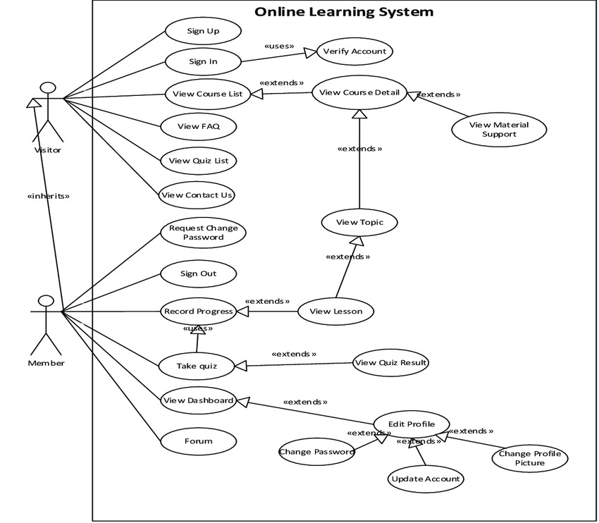

**2.2 Product Function**

Entity Relationship Diagram of Library Management System

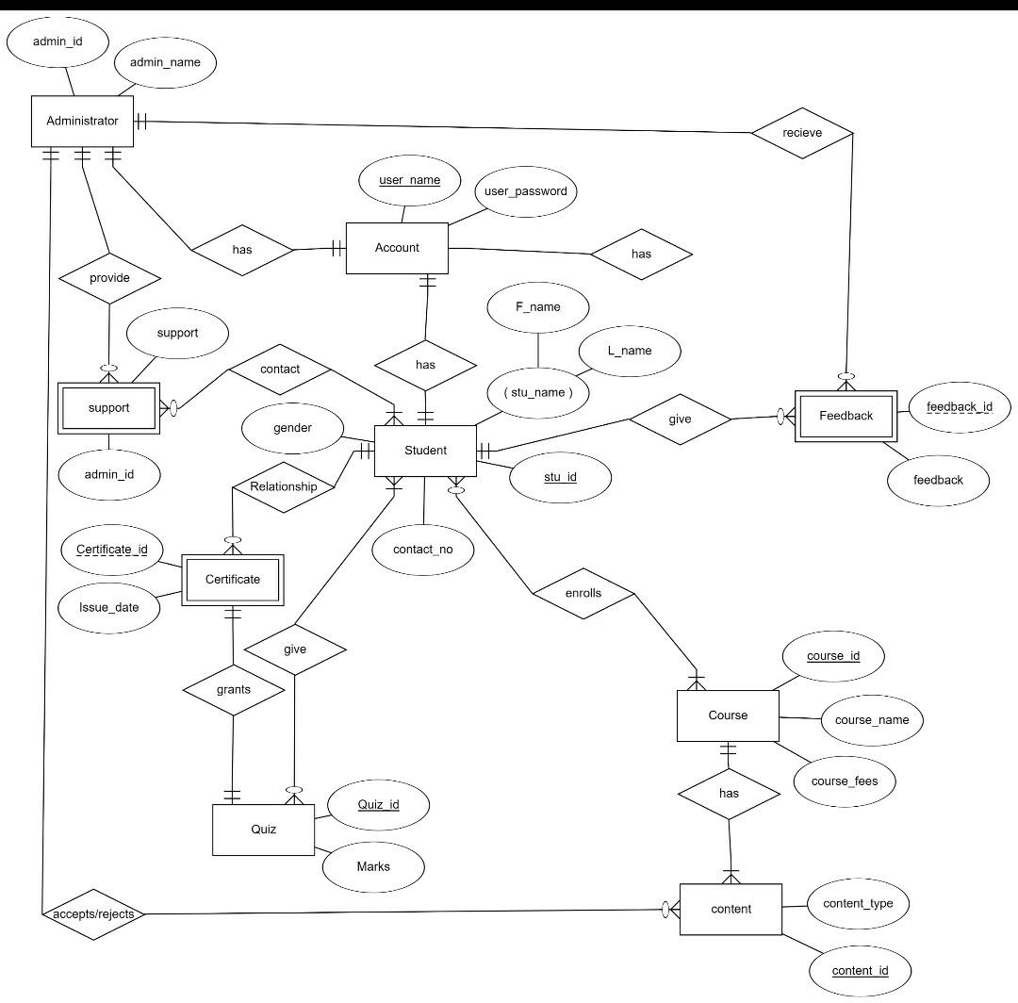

**2.3 User Classes and Characteristics**

User classes are the categories of users who have different roles and permissions in a system. They define the functions and features that each user can access and perform. For an e-learning management system, some common user classes are:

* **Student**: A user who enrolls in courses, accesses lessons, takes quizzes, and tracks their progress. A student can view their own profile, grades, and feedback, but cannot modify the course content or settings.
* **Instructor**: A user who creates and manages courses, lessons, quizzes, and other learning materials. An instructor can also monitor and evaluate the students’ progress and provide feedback and guidance. An instructor can view and edit their own profile, courses, and settings, but cannot access other instructors’ courses or settings.
* **Administrator**: A user who oversees and maintains the system, such as setting up accounts, assigning roles, configuring settings, updating software, and troubleshooting issues. An administrator can view and edit all the profiles, courses, and settings in the system, but cannot enroll in courses or take quizzes.

**2.4 Operating Environment**

The product will be operating in windows environment. The E-learning Management System is a website and shall operate in all famous browsers, for a model we are taking Microsoft Internet Explorer, Google Chrome and Mozilla Firefox Also it will be compatible with the IE 6.0. Most of the features will be compatible with the Mozilla Firefox & Opera 7.0 or higher version. The only requirement to use this online product would be the internet connection. The hardware configuration include Hard Disk: 40 GB, Monitor: 15” Color monitor, Keyboard: 122 keys. The basic input devices required are keyboard, mouse and output devices are monitor, printer etc

**2.5 Assumptions and Dependencies**

**The assumptions are:-**

* The coding should be error free

* The system should be user-friendly so that it is easy to use for the users

* The information of all users, books and libraries must be stored in a database that is accessible by the

website

* The system should have more storage capacity and provide fast access to the database

* The system should provide search facility and support quick transactions

* The E-learning management System is running 24 hours a day

* Users may access from any computer that has Internet browsing capabilities and an Internet connection

* Users must have their correct usernames and passwords to enter into their online accounts and do actions

**The dependencies are:-**

* The specific hardware and software due to which the product will be run

* On the basis of listing requirements and specification the project will be developed and run

* The end users (admin) should have proper understanding of the product

* The system should have the general report stored

* The information of all the users must be stored in a database that is accessible by the E-learning management System

* Any update regarding the book from the library is to be recorded to the database and the data entered should be correct

**2.6 Requirement**

**Software Configuration:-**

This software package is developed using java as front end which is supported by sun micro system. Microsoft SQL Server as the back end to store the database. Operating System: Windows NT, windows 98, Windows XP Language: Java Runtime Environment, Net beans 7.0.1 (front end) Database: MS SQL Server (back end)

**Hardware Configuration:-**

Processor: Pentium(R)Dual-core CPU

Hard Disk: 40GB

**2.7 Data Requirement**

An E-learning management system (LMS) requires diverse data, including user information, course content, administrative settings, enrollment details, assessment scores, communication records, analytics, integration data, compliance information, accessibility preferences, mobile usage data, security logs, backup details, content metadata, and user preferences. Managing this data securely is vital for personalized learning, tracking performance, and complying with privacy standards. The LMS relies on accurate records for user progress, effective communication, and overall system optimization, emphasizing the importance of robust data management practices and adherence to regulatory requirements for a successful and reliable online education platform.

**3. External Interface Requirement**

**3.1 GUI**

The software provides good graphical interface for the user and the administrator can operate on the system, performing the required task such as create, update, viewing the details of the course.

¬ It allows user to view quick reports like Course registered / Completion of the course

¬ It provides course completion and search facility based on different criteria.

¬ The user interface must be customizable by the administrator

¬ All the modules provided with the software must fit into this graphical user interface and accomplish to the standard defined

¬ The design should be simple and all the different interfaces should follow a standard template

¬ The user interface should be able to interact with the user management module and a part of the interface must be dedicated to the login/logout module

**Login Interface:-** In case the user is not yet registered, he can enter the details and register to create his account. Once his account is created he can ‘Login’ which asks the user to type his username and password. If the user entered either his username or password incorrectly then an error message appears.

**Search:-** The member or user can enter the type of course he is looking for and the title he is interested in, then he can search for the required course by entering the course name.

**Categories View:-** Categories view shows the categories of courses available and provides ability to the administrator to add/edit or delete category from the list.

**Administrator’s Control Panel:-** This control panel will allow administrator to add/remove users; add, edit, or remove a resource. And manage course completion.

**4. System Features**

The users of the system should be provided the surety that their account is secure.

**This is possible by providing:-**

¬ User authentication and validation of members using their unique member ID

¬ Proper monitoring by the administrator which includes updating account status, showing a popup if the member attempts to issue number of course that exceed the limit provided by the administrator policy.

¬ Proper accountability which includes not allowing a member to see other member’s account. Only administrator will see and manage all member accounts

**5. Other Non-functional Requirements**

**5.1 Performance Requirement**

The proposed system that we are going to develop will be used as the Chief performance system within the different campuses of the university which interacts with the university staff and students. Therefore, it is expected that the database would perform functionally all the requirements that are specified by the university.

¬ The performance of the system should be fast and accurate

¬ E-learning Management System shall handle expected and non-expected errors in ways that prevent loss in information and long ¬ The system should be able to handle large amount of data. Thus it should accommodate high number of courses and users without any fault

downtime period. Thus it should have inbuilt error testing to identify invalid username/password

**5.2 Safety Requirement**

The database may get crashed at any certain time due to virus or operating system failure. Therefore, it is required to take the database backup so that the database is not lost. Proper UPS/inverter facility should be there in case of power supply failure.

**5.3 Security Requirement**

¬ System will use secured database

¬ Normal users can just read information but they cannot edit or modify anything except their personal and some other information.

¬ System will have different types of users and every user has access constraints

¬ Proper user authentication should be provided

¬ No one should be able to hack users’ password

¬ There should be separate accounts for admin and members such that no member can access the database and only admin has the rights to update the database.

**5.4 Requirement attributes**

¬ There may be multiple admins creating the project, all of them will have the right to create changes to the system. But the members or other users cannot do changes

¬ The project should be open source

¬ The Quality of the database is maintained in such a way so that it can be very user friendly to all the users of the database

¬ The user be able to easily download and install the system

**5.5 Business Rules**

A business rule is anything that captures and implements business policies and practices. A rule can enforce business policy, make a decision, or infer new data from existing data.This includes the rules and regulations that the System users should abide by. This includes the cost of the project and the discount offers provided. The users should avoid illegal rules and protocols. Neither admin nor member should cross the rules and regulations.

**5.6 User Requirement**

The users of the system are members and Librarian of the university who act as administrator to maintain the system. The members are assumed to have basic knowledge of the computers and internet browsing. The administrators of the system should have more knowledge of the internals of the system and is able to rectify the small problems that may arise due to disk crashes, power failures and other catastrophes to maintain the system. The proper user interface, user manual, online help and the guide to install and maintain the system must be sufficient to educate the users on how to use the system without any problems. The admin provides certain facilities to the users in the form of:-

¬ Backup and Recovery

¬ Forgot Password

¬ Data migration i.e. whenever user registers for the first time then the data is stored in the server

¬ Data replication i.e. if the data is lost in one branch, it is still stored with the server

¬ Auto Recovery i.e. frequently auto saving the information

¬ Maintaining files i.e. File Organization

¬ The server must be maintained regularly and it has to be updated from time to time

**6. Other Requirements**

**6.1 Data and Category Requirement**

There are different categories of users namely teaching staff, Instructor, Administrator, students etc. Depending upon the category of user the access rights are decided. It means if the user is an administrator then he can be able to modify the data, delete, append etc. All other users except the Instructor only have the rights to retrieve the information about database. Similarly there will be different categories of courses available. According to the categories of courses their relevant data should be displayed. The categories and the data related to each category should be coded in the particular format.

**6.2 Appendix**

A:Administrator, Abbreviation, Acronym, Assumptions; C: Client, Conventions; D: Data requirement, Dependencies; G: GUI; K: Key; M: Member; N: Non-functional Requirement; O: Operating environment; P: Performance, Perspective, Purpose; R: Requirement, Requirement attributes; S: Safety, Scope, Security, System features; U: User, User class and characteristics, User requirement;

**6.3 Glossary**

The following are the list of conventions and acronyms used in this document and the project as well:

¬ Administrator: A login id representing a user with user administration privileges to the software

¬ User: A general login id assigned to most users

¬ Client: Intended users for the software

¬ SQL: Structured Query Language; used to retrieve information from a database

¬ SQL Server: A server used to store data in an organized format

¬ Layer: Represents a section of the project

¬ User Interface Layer: The section of the assignment referring to what the user interacts with directly ¬ Application Logic Layer: The section of the assignment referring to the Web Server. This is where all computations are completed

¬ Data Storage Layer: The section of the assignment referring to where all data is recorded

¬ Use Case: A broad level diagram of the project showing a basic overview

¬ Class diagram: It is a type of static structure diagram that describes the structure of a system by showing the system’s cases, their attributes, and the relationships between the classes

¬ Interface: Something used to communicate across different mediums

¬ Unique Key: Used to differentiate entries in a database

**6.4 Class Diagram**

A class is an abstract, user-defined description of a type of data. It identifies the attributes of the data and the operations that can be performed on instances (i.e. objects) of the data. A class of data has a name, a set of attributes that describes its characteristics, and a set of operations that can be performed on the objects of that class. The classes’ structure and their relationships to each other frozen in time represent the static model. In this project there are certain main classes which are related to other classes required for their working. There are different kinds of relationships between the classes as shown in the diagram like normal association, aggregation, and generalization. The relationships are depicted using a role name and multiplicities.